
National War Council
“Repair the Breach”
Part 9
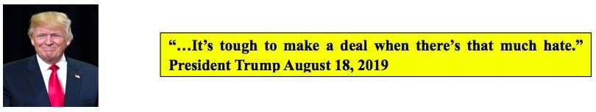

The plan developed by Jared Kushner, (Trump’s son-in-law), Jason Greenblatt, and other senior advisors is for a $50 billion fund to finance 179 business and infrastructure projects with the goal of creating one million new jobs for Palestinians. A senior Israeli official sent a message to the Trump administration about its “red lines” in any future peace agreement; Israel Hayom reported¹ on the 21st (Wednesday). They include:
- An undivided Jerusalem
- No uprooting of settlements
- Complete security control of Judea and Samaria
- No entry of Palestinian “refugees”
Israel’s “Red Lines” (Video)
The Palestinian side has rejected the Trump administration’s peace efforts and has boycotted the administration since the U.S. Embassy was moved to Jerusalem. A historical fact and the delusion that the Palestinian Authority (PLO), Hamas and the small but violent Palestinian Islamic Jihad terrorist group would accept, must less abide by, an agreement reached by other nations further confirms the naivety and inexperience of Trump’s Middle East advisors.
Again, contrary to these great minds of diplomacy, we humbly disagree on what should be relevant to President Trump and his team of envoys. The “War Council” has previously quoted President Trump as saying Israel will “pay a price” for his decision to move the U.S. embassy to Jerusalem and Kushner has stated, “the proposal will force both sides to make tough compromises.”² Again, as previously noted, there is only one side that is being compromised – the sovereign nation of Israel.
With a trillion dollars squandered by the previous administration on “shovel ready” jobs, we believe the American people are no longer deceived by the illusionary grand promises of “politicians” and their penchant to spend taxpayer dollars. There is little tolerance for the continuation of “nation building” in the Middle East – especially for terrorist proxies of Iran.
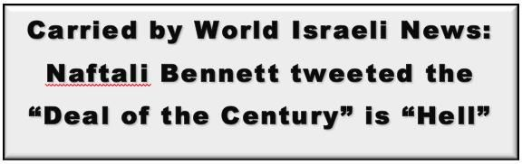
Quoting the World Israeli News staff, “Yemina party member Naftali Bennett tweeted a map on Sunday that he says represents the Trump administration’s coming Arab-Israeli peace plan, or ‘deal of the century.' He says it’s “hell."³
As shown below, the map displays a large black area over most of Judea and Samaria, with small white dots symbolizing Jewish communities connected by thin white lines that symbolize roads. This is the “deal of the century that will be dropped on us immediately after the elections. In black – Palestine. In white – lone Israeli ‘islands’ within an ocean of Palestine. Surrounded 360 degrees by Hamas, Tanzim, PLO.” He went on to state, “hell for every resident of Ariel, Ofra and Kiryat Arba. The end of settlement.”⁴
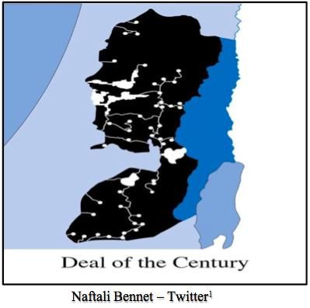
In eight previous position papers, the National War Council has outlined with a map and covenant scripture the land that was promised to Abraham and his descendants. Assuming the picture from Mr. Bennett is accurate, this does not represent a “deal of the century” but more of a naively created “shame of the century” and would be in direct conflict with the “covenant” of the Highest God that “cut” His binding covenant with Abraham.

“Map looks like mud thrown on a wall to see what would stick – a disaster for Israel and her citizens.” Jim Stockstill (debriefing)

Bennett made a passionate pitch for right-wing voters to vote for his party, instead of Likud, “don’t say later that you didn’t know. This is the map. That’s the plan. It will come from a friendly President.” Sadly, for America, he went on to say, “without the counterweight of the right – (Yemeni) – Netanyahu will not be able to withstand Trump’s pressure. To many thousands of Likud supporters, heads of (Judea and Samaria) councils: Wake Up!”⁵
Of course, Bennett’s tweets contradict the “rosier picture painted by Prime Minister Benjamin Netanyahu when he announced his intention to annex the Jordan Valley and northern Dead Sea area during a September 10th press conference.” Netanyahu also said, “he would extend sovereignty over ‘all settlements.’” Responding, journalist Barak Ravid tweeted that Israel might actually receive less than what the map depicts.
In summary Bennett states, “This map is ‘optimistic’ from the point of view of the Right. I am not at all sure that the Trump plan adopts the extent of annexation of the Valley as presented on the Netanyahu map (about 17 percent of the West Bank only annexation in the Valley). In my opinion, the Trump plan will include annexation of 10-15 percent of the West Bank.”⁶
Starting with our first position paper on the Trump Israeli Peace Plan (TIPP), we have objectively viewed the effort of the Middle East envoys in light of scripture (Torah) and the eternal “covenant “Jehovah made with Abraham and his descendants for the Promised Land. In Psalms 105 the psalmist wrote beginning in verse (6) through (11):
“O you offspring of Abraham His servant, you children of Jacob, His chosen ones, He is the Lord our God: His judgement are in all the earth. He is [earnestly] mindful of His covenant and forever it is imprinted on His heart, the word which He commanded and established to a thousand generations, the covenant which He made with Abraham, and His sworn promise to Isaac, which He confirmed to Jacob as a statute, to Israel as an everlasting covenant, saying, ‘unto you will I give the land of Canaan as your measured portion, possession and inheritance.’”
Finally, the “Deal of the Century” is nothing more than a gerrymandered attempt at resolving the centuries long dispute between two brothers – Jacob and Esau. Remove the naivety of dealing with the Palestinian Authority, Hamas (who the Israeli Prime Minister now wants to eradicate) and the Palestinian Islamic Jihad along with the consequences of trespassing scriptural warnings and Israel ends up with nothing more than a third-party negotiated “Shame of the Century” deal. Please do not follow this ill-conceived plan Mr. President.
As the National War Council, we fully support your Presidency and genuinely appreciate the leadership you have shown in recognizing Jerusalem as the rightful capital of Israel and thereafter moving the U.S. Embassy to the “Golden City.” This “deal” will exact a heavy toll on you and be harmful to the United States of America. We continue to pray for the Divine hand of guidance on you and the decisions you face daily as well as favor and protection by the God of heaven and earth.
[August 26, 2019]
Blessings,
Joseph “Jim” Stockstill 
The Unknown Prophet in Texas
“National War Council” – Chairman, Formation Committee
Dallas Metroplex
war.council@yahoo.com
PayPal.Me/warcouncil

“For the weapons of our warfare are not carnal but mighty through God…”
II Corinthians 10:4

Text Credits:
- Ariel Kahana, “Israel makes red lines clear as Washington prepares peace plan,” Israel Hayom, August 21, 2019. https://www.israelhayom.com/2019/08/21/israel-makes-red-lines-clear-as-washington-prepares-to-unveil-peace-plan/
- Eric Cortellessa, “With new elections in Israel, Trump’s peace plan hits another hitch,” The Times of Israel, June 1, 2019. https://www.timesofisrael.com/with-new-elections-in-israel-trumps-peace-plan-hits-another-hitch/
- World Israel News, “Bennett reveals Trump’s ‘Deal of the Century’ map – ‘it’s hell,’” World Israel News, September 15, 2019.
https://worldisraelnews.com/naftali-bennett-reveals-deal-of-the-century-map-its-hell/
- World Israel News, “Bennett reveals Trump’s ‘Deal of the Century’ map – ‘it’s hell’”
- World Israel News, “Bennett reveals Trump’s ‘Deal of the Century’ map – ‘it’s hell’”
- World Israel News, “Bennett reveals Trump’s ‘Deal of the Century’ map – ‘it’s hell’”

Image Credit:
- Naftali Bennet

