
National War Council
“Repair the Breach”
Part 8
Trump’s Israel Peace Plan (TIPP) Hits Another Hitch

“Former US diplomats and Mideast experts say that time is working against the proposal as the US election campaign will be in full swing by the time Israel has a government.”¹

Prime Minister Benjamin Netanyahu’s stunning defeat earlier this week, when he failed to form a majority coalition and called new elections, threw Israel into a period of political paralysis and uncertainty. As we previously mentioned this possibility in warning the Prime Minister not to enter negotiations for peace which included land, his likely defeat in September may result in TIPP not seeing “the light of day any time soon.”
“Obviously, it means putting off until after the government is formed,” said Ambassador Dennis Ross, a veteran American diplomat who has worked on the Israeli-Palestinian portfolio for decades. “That means, given the timing of the election and the holidays, you’re looking at November,” Ross told The Times of Israel. “Then the question is, how committed is the administration in going ahead at this point, since our own election will be getting underway?”²
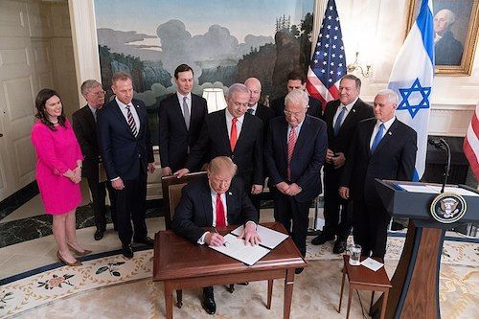
Again, contrary to these great minds of diplomacy, we humbly disagree on what should be relevant to President Trump and his team of envoys. The “War Council” has previously quoted President Trump as saying Israel will “pay a price” for his decision to move the U.S. embassy to Jerusalem and Kushner has stated, “the proposal will force both sides to make tough compromises.”³ No, there is only one side that is being compromised – the sovereign nation of Israel.
The relevant question for President Trump, and his potential for reelection is 2020, is really simple. Is the President willing to “put forth a plan that has components unpopular to major parts of his base?”⁴ As if any part of TIPP is popular among his strong base of evangelicals and Orthodox Jews, the inclusion of a two-state solution would enrage and rapidly erode his support among these critical voting blocs.
The fact is that a two-state solution is nonsense and the typical DC political parlance which Mr. Donald J. Trump promised during his campaign would never happen in his administration is following the same naive and deceiving blueprint of previous administrations. How can there be a two-state solution when Israel is already a recognized nation with its own capital?
On the other hand, the Palestinian Authority or Palestine, is a region not a state regardless of many in the United Nations that falsely claim otherwise. Another complicated element of the Palestine territory includes Iranian backed terrorist proxies like the Palestinian Islamic Jihad (PIJ) and Hamas who tunnel their way into the sovereign borders of Israel to attack unsuspecting Israelis, fire rockets/missiles on innocent civilians, riot at the border, kill Jews whenever possible and reward the families of those that commit atrocities against Jews with a substantial monthly stipend. In the past, these funds were paid by the American taxpayer.

Meanwhile, those anxious to find out what ultimately will be in the ostracized Trump peace plan should not hold their breath. According to Aaron David Miller, a longtime Mideast peace negotiator in both Democratic and Republican administrations states, “My sense is that they’re factoring in three things: not failing, not making things worse for Netanyahu, and always keeping their eye on 2020.” And while there is some debate as to the meeting actually occurring, Miller told The Times of Israel, “the meeting will take place, at least to convince regional actors that they are, in fact, working on a peace plan. I think Bahrain will go on as what I call ‘proof of life’ that, in essence, something exists called the Kushner plan.”⁵
Others, like Susie Gelman, board chair of the Israel Policy Forum, an advocacy group for a two-state solution states, “I think there are real questions about the utility of such an effort under any circumstances, but especially now. They’re not going to be able to hold the economic workshop and then follow it up with the political plan in a timely manner.”⁶
The “War Council” agrees, paradoxical to their “great meeting” with King Abdullah of Jordan, Mr. Kushner has stated that the conference will not include core political issues, such as Palestinian statehood. Nevertheless, from an historical standpoint and timing, contrary to promises made by diplomats and politicians, the conference (workshop) will more than likely move forward and certainly attendees will attempt to address the two contentious elements; economic and political. Along with Sunnis and Shiite nations, as well as China and Russia, the President’s key base of supporters within the ecumenical community will be carefully watching as well.
What is the land that God promised to Israel?
In regards to the land that Jehovah has promised Israel, Genesis 15:18 declares to Abraham; “To your descendants I give this land, from the river of Egypt to the great river, the Euphrates.” God later confirms this promise to Abraham’s son Isaac and Isaac’s son Jacob (whose name was later changed to Israel). When the Israelites were about to invade the Promised Land, God reiterated the land promise, as recorded in Joshua 1:4, “Your territory will extend from the desert to Lebanon, and from the great river, the Euphrates—all the Hittite country—to the Great Sea on the west.”
According to Genesis 15:18 and Joshua 1:4 the land God gave to Israel included: everything from the Nile River in Egypt to Lebanon (south to north) and everything from the Mediterranean Sea to the Euphrates River (west to east). Translated today, Jehovah gave Abraham and his descendants all of the land modern Israel currently possesses, all of the land of the Palestinians (the West Bank and Gaza), all the land of Jordan, some of Egypt, Syria, Iraq and Saudi Arabia. Sadly, for the Jewish descendants, it is easy to see the original “Promised Land” has been drastically altered from the “covenant” Jehovah made with Abraham.
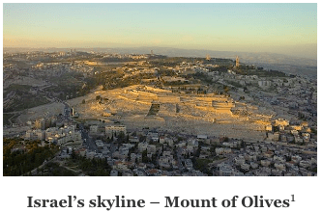
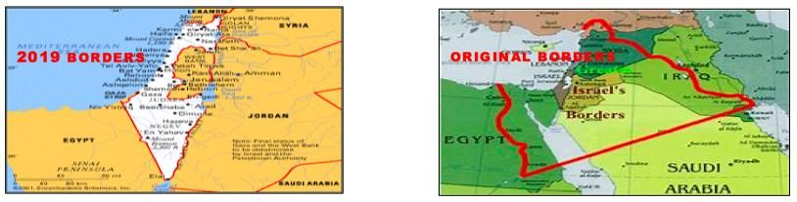
Israel is 8,019 sq. miles in area, comparable to the size of New Jersey. Israel's land area could fit into the state of Florida just over eight times.
Israel's population density (8.5 million) is also comparable to that of New Jersey, which has a population of around 8.8 million. It is a very urbanized nation as over 90 percent of its population lives in an urban area. Its most population-dense location is the Tel Aviv. Israel's population has a median age of about 30 years old.
One State Solution for Palestine

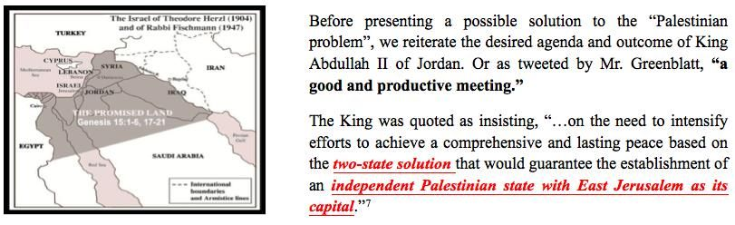
History:
In 1948 the leader of the Jews David Ben-Gurion declared an independent Jewish country named Israel according to this plan. The local Arabs, assisted by armies of the neighboring Arab countries, attacked this state, beginning a war called “The War of Independence” in Israel. Israel won, in the sense that it did not succumb and kept its sovereignty within borders that were larger than what the 1947 UN plan allotted it. When a ceasefire was reached, the northern part of the lands that were supposed to become an Arab state (Western Galilee) became Israeli territory and the Arabs who lived there received Israeli citizenship. The central part, known as Judea and Samaria or the West Bank, became part of the Kingdom of Jordan, and the southern part, known as the Gaza strip became part of Egypt. In the process many Arabs left their homes, and became known as the Palestinian refugees.
There is not a nation among the Arabs, Persians, Turks, Jordanians or the countries of North African that wanted the Palestinian refugees. With large swaths of land, many in the Arab League could have offered and settled the Palestinians in one of their countries once and for all. Instead, with the destruction of Israel as their goal, the defeated nations pushed them off on the Jewish state.
Latest Population Census:
According to the Palestinian Central Bureau of Statistics (PCBS), there are an estimated 5,191,527 Palestinians in the Palestinian territories as of 2019, of whom 3,166,831 live in the West Bank and 2,024,696 in the Gaza Strip. According to the Israel Central Bureau of Statistics, there were 1,658,000 Arab citizens of Israel as of 2013.
One State Solution for Palestine (Two Options)
The following map shows two locations for the Palestinians that would be more than adequate for their resettlement and potential to form a state:
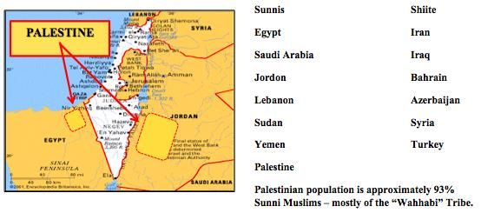

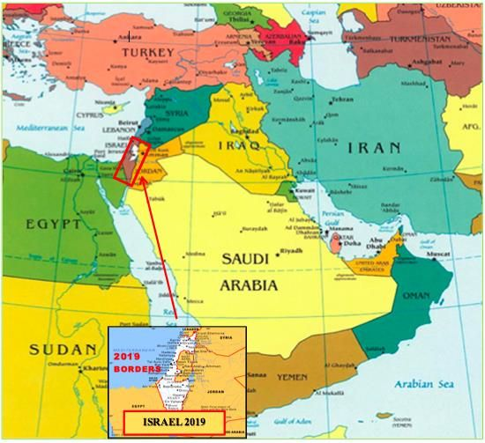

One State Solution for Palestine

Jordan is Palestine - Palestine is Jordan
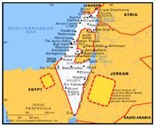
This is the royal decree and sentiments of two of the kings of Jordan. King Abdullah I stated in 1948, “Palestine and Jordan are one…” Again in 1981, his son King Abdullah II reiterated his father’s decree by stating, “The truth is that Jordan is Palestine and Palestine is Jordan.”⁸ This is true in marriage as well, Queen Rania Al-Abdullah was born in Kuwait to a Palestinian family.
Accordingly, Abdul Hamid Sharif, Prime Minister of Jordan declared in 1980, “The Palestinians and Jordanians do not belong to different nationalities. They hold the same Jordanian passports, are Arabs and have the same Jordanian culture.”⁹ In other words, Jordan is Palestine - Arab Palestine. There is absolutely no difference between Jordan and Palestine, nor between Jordanians and Palestinians. Moreover, according to Farouk Kaddoumi, then head of the PLO Political Department, who gave the statement to Newsweek, “There should be a kind of linkage because Jordanians and Palestinians are considered by the PLO as one people.”¹⁰
“There is no such thing as ‘Palestine’ in history”
According to Arab-American columnist Joseph Farah, “Palestine has never existed – before or since – as an autonomous entity. It was ruled alternately by Rome, by Islamic and Christian crusaders, by the Ottoman Empire, and briefly by the British after World War I. The British agreed to restore at least part of the land to the Jewish people as their homeland. There was no language known as Palestinian. There was no distinct Palestinian culture. There has never been a Palestine governed by the Palestinians. Palestinians are Arabs, indistinguishable from Jordanians (another recent invention), Syrians, Lebanese, Iraqis, etc.”¹¹
The “National War Council”
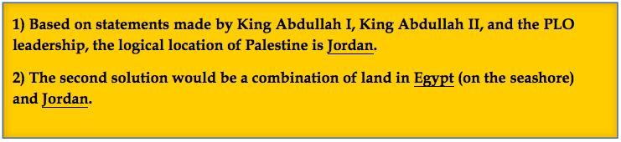
While the Trump negotiating team, and nearly every nation in the Middle East, want to further carve-up Israel and divide Jerusalem, these sages have not looked at the obvious solution to the Palestinians and their desire for a State. With the population of more or less 5 million, divided between the West Bank and Gaza Strip, the Palestinians need a geographic area about the size of Harris County (Houston, Texas). We offer the following two options:

International Aid for Palestine
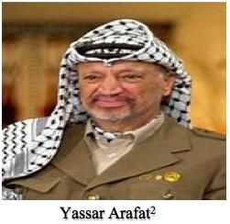
Yasser Arafat, Former Chairman of the Palestine Liberation Organization. One mystery of his life seemed unsolved at the time of his death: How much money did he have, and where is it? In the mid-1990s, Arafat controlled a financial empire worth at least $3 billion. By the time of his death, he was down to his last $1 billion, according to Israeli intelligence estimates. Palestinian leaders believe his widow Suha would like to make off with what is left of his cash, a suspicion deepened by her charges that Arafat's successors were "trying to bury Abu Amar (Arafat) alive."¹²

What Are Palestinians Doing with U.S. Money?
The Oslo peace process provided a brief windfall for the Palestinians, bringing Arafat $4.5 billion in donations from the U.S., the European Union, Japan and sales tax gathered by Israel that was passed on to him. But much of that was wasted or skimmed by corrupt Arafat associates. When a Palestinian Authority audit exposed the corruption in 1997, Arafat ordered future audits to be kept secret. Palestinian economic analysts estimate that the PA has received a total of $25 billion in financial aid from the U.S. and other countries during the past two decades.
One does not have to be an expert on Palestinian affairs to see that the billions of dollars have neither created democracy for the Palestinians nor boosted the Israeli-Palestinian peace process. Twenty years later, the Palestinians still have a long way to go before they ever see real democracy in the West Bank or Gaza Strip.
Those who were funding Arafat's autocratic regime back then never cared about either democracy or transparency. They were pouring billions of dollars into the PA without holding its leaders accountable. The result was that the Palestinians got a regime that not only deprived them of most of the international aid, but that also cracked down on political opponents and freedom of speech. The Palestinian Authority was actually a one-man show called Yasser Arafat; he and his cronies were the main benefactors of American and European taxpayers' money.
The refusal of the international community back then to hold Arafat accountable was the main reason a majority of Palestinians were driven into the open arms of Hamas. Palestinians lost faith not only in the peace process, but also in the Palestinian Authority and its leaders. Palestinians saw no improvement in their living conditions, mainly as a result of the PA's corruption. That is why they turned to Hamas, which promised them change, reform, and an end to financial corruption. The Americans and Europeans therefore are basically responsible for Hamas's rise to power.

Relocation for Palestine

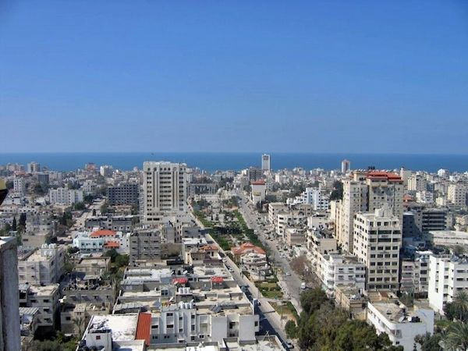
As the “War Council” has pointed out, billions and billions of dollars have been poured into efforts to establish a safe and secure land for the Palestinians. Sad, but a reality, the funds have been squandered on select leaders, their cronies, and purchasing a massive arsenal of weapons from their benefactor Iran. By skimming money, leaders of both the Palestinian Authority and Hamas have become millionaires, even billionaires, while their people suffered shortages of food, water, health care and safety.
Solution for the Palestinian people
The incentives of just another economic summit (or workshop), usually results in throwing more money at the problem, but this approach has never worked and will never solve the problems facing the day-to-day hardworking citizens of Palestine. The United States and other countries have tried this (bribery) and each time it results in criminals (both the PA and Hamas taking the funds and absconding to nations that provide a safe haven.
The New State of Palestinian
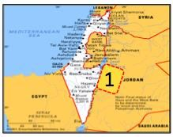
Palestinians in the West Bank and Gaza will move to The New State of Palestine over a two-year period beginning in 2021. Once the plan is presented to the Palestinian people new elections will be held to form a legitimate government that will unify the various factions. The newly formed government will then be in a position to sign an agreement between participating parties and ratified by the United Nations.
The Arab League: Contribute $20 billion ($17 billion to construct New State of Palestine) Infrastructure: a modern airport, roads, bridges, water treatment, sewage treatment, energy for electricity (solar, oil, natural gas, etc.) government buildings, police stations, etc. $3 billion will be paid to the Royal House of Jordon for the land and administration of funds.
The European Union: Contribute, $6 billion hotels, resorts, homes, apartments, farms, irrigation, equipment, etc.
Other Nations: $4 billion, (Canada, Australia, Hong Kong, etc.) assist in building manufacturing facilities to export products, and training for skilled labor for employment.
The United States: $3 billion, modern train that runs from the heart of the city to a station in Jordon connecting with a newly constructed interstate that arrives just outside the Old Jerusalem for easy accessibility to the Dome of the Rock.
$30 billion to build a new State the size of Harris County Texas and $3 billion for the land.

[June 5, 2019]
Blessings,
Joseph “Jim” Stockstill 
The Unknown Prophet in Texas
“National War Council” – Chairman, Formation Committee
Dallas Metroplex
war.council@yahoo.com
PayPal.Me/warcouncil

“For the weapons of our warfare are not carnal but mighty through God…”
II Corinthians 10:4

Text Credits:
- Eric Cortellessa, “With new elections in Israel, Trump’s peace plan hits another hitch,” The Times of Israel, June 1, 2019. https://www.timesofisrael.com/with-new-elections-in-israel-trumps-peace-plan-hits-another-hitch/
- Eric Cortellessa, “With new elections in Israel, Trump’s peace plan hits another hitch”
- Eric Cortellessa, “With new elections in Israel, Trump’s peace plan hits another hitch”
- Eric Cortellessa, “With new elections in Israel, Trump’s peace plan hits another hitch”
- Eric Cortellessa, “With new elections in Israel, Trump’s peace plan hits another hitch”
- Eric Cortellessa, “With new elections in Israel, Trump’s peace plan hits another hitch”
- The Times of Israel, “Jordan king tells Trump team a Palestinian state the only way to peace,” The Times of Israel, May 29, 2019. https://www.timesofisrael.com/jordan-king-tells-trump-team-a-palestinian-state-the-only-way-to-peace/
- Gary Fitleberg, “Jordan is Palestine,” Israel National News, February 2, 2004. http://www.israelnationalnews.com/Articles/Article.aspx/3287
- Gary Fitleberg, “Jordan is Palestine”
- Rachel Avraham, “Trump Resurrects the Idea of Jordan Is Palestine,” The Christian Post, September 7, 2018. https://www.christianpost.com/voice/trump-resurrects-the-idea-of-jordan-is-palestine.html
- Jason Maoz, “Joseph Farah, Mythbuster,” Jewish Press, March 3, 2010. https://www.jewishpress.com/indepth/media-monitor/joseph-farah-mythbuster/2010/03/03/
- By Julie Stahl, “'They're Trying to Bury My Husband Alive' Suha Arafat Says,” CNS News, July 7, 2008.
https://www.cnsnews.com/news/article/theyre-trying-bury-my-husband-alive-suha-arafat-says

Image Credits:
- Andrew Shiva
- Government Press Office (Israel)

