
National War Council
“Repair the Breach”
Part 11
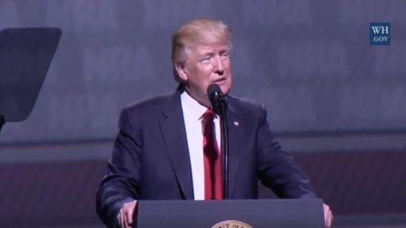

The Expediency of Politics

According to Barak Ravid, a diplomatic correspondent for Israel’s Channel 13, President Donald Trump is about to decide whether a long-awaited plan on the future of Israelis and Palestinians should be made public in the coming weeks, or if he should wait even longer until after the March 2 Knesset election, reports Axios. “It could influence the campaign and possibly provide a boost to embattled Prime Minister Benjamin Netanyahu,” says Ravid. “If Trump decides to wait, it could become difficult to present the plan at a later stage because of the presidential election in the U.S.,” added the correspondent.¹
Ravid went on to say that “Netanyahu wants the White House to present the plan in order to shift the focus of his campaign away from his corruptions cases. Gantz² wants the White House to wait and has even argued that releasing the peace plan ahead of the elections would amount to electoral interference.” Finally, in his report, in which he cites U.S. and Israeli sources, Ravid says, “Trump’s decision will be influenced by several factors.”
- Developments in the impeachment process in Congress.
- The meetings Trump and his senior adviser Jared Kushner will have with different leaders from the Middle East and Europe during the World Economic Forum in Davos this week, where the peace plan will be one of the topics raised.
- Kushner is expected to travel from Davos to Jerusalem on Wednesday to participate in the Fifth World Holocaust Forum, where he is likely to meet Netanyahu and his political opponent Benny Gantz — the leader of the Blue and White party — and discuss the peace plan.³
As the National War Council has previously reported, these are the same Middle East negotiations that the Palestinian Authority leadership has boycotted⁴ (including terrorist groups; Palestinian Islamic Jihad, which is a Damascus-based Palestinian Islamist terrorist organization and the notoriously brutal Hamas which controls the Gaza Strip).
“The reason that the release of the plan before the election is considered a move that could boost the chances of success of Netanyahu’s Likud party in the March election is that the so-called ‘Deal of the Century’ is believed to be more sympathetic to the Israeli right-wing vision for the future of Judea and Samaria than previous U.S. peace plans, though Defense Minister Naftali Bennett has warned that the Trump plan would deal a blow to the future of Israeli settlement activity in those regions.”⁵
However, our opposition to the plan is that it conflicts with Scripture – and there is a rational and viable alternative option as the National War Council has previously stated. This option, relocating Palestine to Jordan, is in line with the “covenant” that Jehovah made with Abraham, and Scripture in the Torah.
As we have shown before, Defense Minister Bennett has provided a “map” of what TIPP, or in actuality the “Kushner Plan” will look like if the deal is presented and approved:
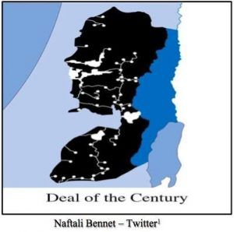
Bennett, a Yemina party member, stated, “Trump administration’s coming Arab-Israeli peace plan, or “deal of the century.” He says it’s “hell. This is the ‘deal of the century’ that will be hell for every resident of Ariel, Ofra and Kiryat Arba – the end of settlements.” He noted, in black is Palestine and in white – “lone Israeli ‘islands’ within an ocean of Palestine. Surrounded 360 degrees by Hamas, Tanzim, and the PLO.”⁶
Again, this “deal of the Century” is not about what is right, and it is diametrically in opposition to the “covenant” Jehovah made with Abraham, Isaac, Jacob and their descendants (Genesis 12:3). Like all political masquerading and parlance, this “deal” is simply about ego and some misguided conception of achieving a great historic legacy. Besides being rooted in naivety, the “the Kushner Plan” is an invitation to undo the exceptional leadership shown by President Trump in acknowledging Jerusalem as the rightful capital of Jerusalem and thereafter relocating the U.S. Embassy to Jerusalem. Not only suggesting such an outlandish deal, but also the potential of implementation will bring the promised curse on the President and the United States of America.
In the course of publishing ten previous position papers including two viable alternatives for the Palestinians, the National War Council has based our opposition on the Holy Word of Jehovah in the Torah and always keeping what is best for the sovereign nation of Israel at the forefront.
It is obvious the sages that have crafted this monstrosity have forgotten about Persia (Iran) or at least the Supreme Leader and Mullahs in Qom and Tehran. From the Qur’an and the Shias, there are scriptures that cannot be avoided when dealing in the Middle East – with either Shia or Sunnis followers.
Quoting Sura 2:218 from the Qur’an; “Surely those who believe, those who wage jihad in God’s cause are the ones who may hope for the mercy of God.” Jews and Christians are the ones whom God has cursed, they “shall either be executed, or crucified, or have their hands and feet cut off alternately, or be banished from the land.”
Quoting Sura 9:5 “Whenever you may come upon them, and seize them, and confine them, and lie in wait for them at every conceivable place.” Infidels (those not practicing Islam) according to Sura 22, will spend eternity in a blazing fire, “with boiling water being poured down over their heads. All that is within their bodies, as well as their skins, will be melted away.” Further, “Have nothing to do with them, don’t befriend them. Don’t negotiate with them. Don’t do business with them.”
Sura 5:59-60, “Allah has cursed the Christians and the Jews, and those whom he has utterly condemned he has already turned into apes, and swine, and servants of powers of evil.”
While many compromising and politically correct clergy and politicians placate and tell the American people that Islam is a peaceful religion, they ignore the realities of centuries of bloodshed. Are there good, law abiding Muslims – absolutely. Are there fanatics that take the Holy Word of their Qur’an literally – absolutely. And as I have pointed out before, this tribal infighting in the Middle East has existed since Isaac and Ishmael followed by Jacob and Esau. There is no young, exceptionally talented real estate businessman that will be able to equitable settle this family feud in the Middle East with compromise (land), blackmail (withhold military funding from Israel), bribery (billions have been wasted and lined the pockets of corrupt leaders in the PA and terrorist organizations like Hamas) and empty promises of building a utopian state for the Palestinians. Move them to Jordan, Israel is already a sovereign nation recognized by the United Nations.
As avid supporters Mr. President, please do not listen to the misguided advice you have received regarding the deal that is in your name only (TIPP) – it is the efforts of a young team of inexperienced envoys that are leading you and this nation into potential disaster. Prophetically warned, you can see firsthand the trouble (curse) it has brought upon (former) Prime Minister Benjamin Netanyahu and his lovely wife Sara.
As the National War Council, we avidly support you in every way except when you or your policies violate Scripture and the “covenant” the Most High God made with Abraham and his descendants. We appreciate you and the First Lady and pray for each of you daily. May God provide divine guidance in your dealing with Israel, His Holy Word and our amazing nation.
January 20, 2020

Blessings,
Joseph “Jim” Stockstill 
The Unknown Prophet in Texas
“National War Council” – Chairman, Formation Committee
Dallas Metroplex
war.council@yahoo.com
PayPal.Me/warcouncil

“For the weapons of our warfare are not carnal but mighty through God…”
II Corinthians 10:4

Text Credits:
1 Barak Ravid, “Trump to decide in coming days on when to release Middle East peace plan,” Axios, January 19, 2020. https://www.axios.com/trump-israel-palestine-peace-plan-elections-4e12120a-260d-49b2-840b-1f5ddb457db5.html
2 Wikipedia, “Benny Gantz,” Wikipedia, December 2018. https://en.wikipedia.org/wiki/Benny_Gantz
3 Ravid, “Trump to decide in coming days on when to release Middle East peace plan”
4 World Israel News Staff, “Abbas calls US-led Bahrain conference ‘a big lie that Kushner invented’,” World Israel News, July 5, 2019. https://worldisraelnews.com/abbas-calls-us-led-bahrain-conference-a-big-lie-that-kushner-invented/
5 World Israel News Staff, “Bennett reveals Trump’s ‘Deal of the Century’ map – ‘it’s hell’,” World Israel News, September 15, 2019. https://worldisraelnews.com/naftali-bennett-reveals-deal-of-the-century-map-its-hell/
6 World Israel News Staff, “Bennett reveals Trump’s ‘Deal of the Century’ map – ‘it’s hell’”
Image Credit:
1. Naftali Bennet

