
National War Council
“Repair the Breach”
Part 10
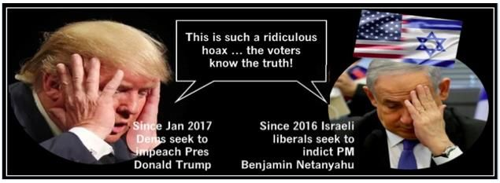
In a prophetic warning on March 12, 2019, I quoted from the Torah the covenant Elohim (“Supreme One” – all powerful God) made with Abraham, Issac and Jacob (Israel) and their descendants to no avail.
In regards to the land that Jehovah has promised Israel, Genesis 15:18 declares to Abraham; “To your descendants I give this land, from the river of Egypt to the great river, the Euphrates.” God later confirms this promise to Abraham’s son Isaac and Isaac’s son Jacob (whose name was later changed to Israel). When the Israelites were about to invade the Promised Land, God reiterated the land promise, as recorded in Joshua 1:4, “Your territory will extend from the desert to Lebanon, and from the great river, the Euphrates—all the Hittite country—to the Great Sea on the west.”
In every case when a nation’s leader has tried to alter the covenant of Jehovah relative to the land of Israel, and particularly Jerusalem, it has not gone well for the individual or the nation. The covenant in Genesis 12:3, “I will bless those who bless you and whoever curses you I will curse; and all peoples on earth will be blessed through you” is eternal.
Regrettably, there has been a string of U.S. Presidents, Israeli leaders, and others that have tried (and often succeeded) to alter the boundaries and divide Jerusalem. The efforts of Trump’s envoys to the Middle East, along with a nod from the former Prime Minister of Israel (Benjamin Netanyahu) has already proven disastrous for both leaders even before the official release of the “Deal of the Century” – the Trump Israel Peace Plan.
While the Prime Minister of Israel was previously warned not to negotiate any part of the promised land, he ignored that warning and was turned out of office in 1999. Once again, with direct warning but wanting to please the President, he silently agreed to the negotiating process initiated by Jared Kushner (a longtime friend) and the envoy team. Once the negotiations began attracting international news, and the Israeli government stated it was cautiously optimistic, trouble began for the Netanyahu family.
On June 21, 2018 Attorney-General Avichai Mandelblit filed an indictment against the prime minister’s wife, Sara Netanyahu, for fraud and aggravated circumstance and breach of public trust in defrauding the government of $100,000. Nearly a year later under a mutual agreement, fraud charges were reduced to a lesser offense and Mrs. Netanyahu pleaded guilty paying a fine of $2,775, and reimbursement of expenses ($12,490).
For the Prime Minister, a key ally needed in negotiating and passing TIPP, the Israeli elections held on September 17, 2019 also proved disastrous. Once he was defeated, and although President Reuven Rivlin tasked him with forming a unity government following the deadlocked election, he has been unable to succeed. As of this writing, December 12, 2019, neither Mr. Netanyahu nor his opposition (Benny Gantz) has succeeded in forming a new coalition government. If the Blue and White and Likud parties are not able to form a government, Israelis will face an unprecedented third election on March 2, 2020.
And what affects has negotiating the “Deal of the Century” had on President Donald J. Trump before its official release? As a prophetic/seer, I believe the two years of ongoing investigations into the false (hoax) “Russian Collusion,” and now the “whistleblower complaint” concerning the President repeatedly pressuring Ukraine to investigate Hunter Biden (son of former Vice President Joe Biden), has lead Democrats to move forward with a new set of investigations and talk of impeachment. The majority of the 235 Democrats in the House have previously supported an impeachment inquiry based on former Special Council Robert Muller’s report regarding “Russian Collusion.”
President Trump acknowledging Jerusalem as the official capital of Israel and moving the embassy to Jerusalem was historic and showed exceptional leadership. The idea of negotiating peace in the Middle East which also began in the first year of Donald Trump’s Presidency was naive and misguided by his closest Middle East advisors. This was shocking in two ways. First, the key envoy leaders (Greenblatt and Kushner) were Jewish descendants of “the Holocaust,” and secondly, the inner-circle of advisors seem oblivious or condescending to the Holy writ and warnings in the Torah.
Regarding the two leaders, one has been turned out of office for the second time and the other has been besieged with partisan attacks from both appointed and elected leaders – all of this without TIPP being released. And a final note on President Trump, it has been reported that he is furious with both the Prime Minister (former) of Israel and the Israeli elections because he/they have delayed the unfurling and disclosure of the “Deal of the Century.” As an unabashed supporter of the President, understanding the curse that an individual and/or nation may incur when violating scripture, and an eternal covenant made by Adoni, I pray that the Trump Israel Peace Plan never sees the light of day.
Lastly and nauseating to anyone that believes Israel is a sovereign nation, and that Jerusalem (Psalm 137:5) is particularly special to God, the majority of the members of the United States House of Representatives have irrevocably “poked God in the eye.”
The Democratically-controlled Congress on Friday (December 6, 2019) approved a Two-State Solution resolution calling for Israel to be divided and the land given to create a Palestinian State.
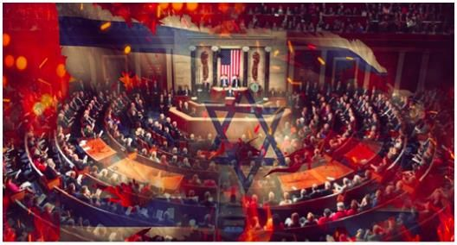
Amazing, but not startling, Democrats have continually criticized President Trump for acknowledging Jerusalem as the official capital of Israel, moving the U.S. Embassy to Jerusalem, recognizing Israel’s sovereignty over the Golan Heights, and cutting the majority of U.S. aid to the Palestinians. Getting to the heart of why they despise the President, according to Democrats, these moves “endanger” a two-state solution for the Palestinians. Lest we forget, there is no need for a two-state solution as Israel is already a sovereign nation as of May 14, 1948.
Only five Republicans backed the measure in the 226-183 vote, although eleven GOP lawmakers joined a bipartisan amendment reaffirming U.S. commitments to providing military aid to Israel that was added. On a side note, “The Squad”, comprised of socialists and Muslims, also voted against the resolution because it included the aid to Israel which they vehemently oppose.
Finally, in the end, the one who ultimately wants to “divide the land” as described in Joel 3:2 – is the same that said he will be “like the most high” – Satan. Elohim has only one sovereign nation that He made by covenant, the “Promised Land” made with Abraham and his descendants. See Part 1 for a current map of what Israel possesses today and what was promised.
Meanwhile, I pray for the President and our amazing nation, the United States of America – “the land of the free and home of the brave.”
Blessings,
Joseph “Jim” Stockstill 
The Unknown Prophet in Texas
“National War Council” – Chairman, Formation Committee
Dallas Metroplex
war.council@yahoo.com
PayPal.Me/warcouncil

“For the weapons of our warfare are not carnal but mighty through God…”
II Corinthians 10:4

