
National War Council
“Repair the Breach”
Part 6
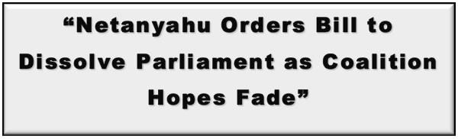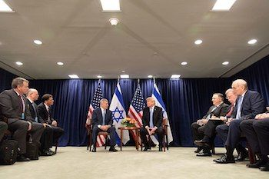
We appreciate Prime Minister Netanyahu and his leadership over the years representing and defending Israel. NEVERTHELESS, he was prophetically warned (face-to-face) about negotiating any deal or treaty that would compromise the land promised to Abraham, Isaac, Jacob and their descendants. As with the President of the United States, the Arab League or the Prime Minister, it is not his to negotiate. In earlier writings I clearly stated the Prime Minister was warned against negotiating deals that included the “Covenant Land” (Genesis 12:7, 13:15, 17:18, Deuteronomy 1:8, etc.). He was removed from office once previously for not heeding a clear verbal warning given to him, and he may be removed from office once again for repeating the same senseless mistake.
The God of heaven and earth will not be mocked (Galatians 6:7) when He makes a “Covenant!” Though men and nations break treaties/covenants routinely, Jehovah honors His Word and NEVER breaks a Covenant. Why should the potential defeat of Prime Minister Netanyahu concern the ecumenical community? Simply, the same warning has been given to the TIPP negotiating team as well as the President of the United States. To continue down this ludicrous path does not bode well for him or the nation.
As the “National War Council”, when we think the naivety and arrogance of the negotiating team for the President cannot get anymore audacious, they find ways to confound and astound. This is the new angle:
“Trump chooses Arab League over PLO to end conflict with Israel”
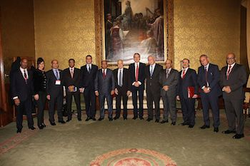
Arab League¹
According to David Singer and other sources of leaks, “President Trump has finally given up on the Palestine Liberation Organization (PLO) negotiating with Israel to end the Jewish-Arab conflict by decisively moving to involve the Arab League to fill that negotiating void.”¹
Disappointingly, what appears to be an illogical replacement of the defiant and treacherous leadership of the PLO/Hamas with the Arab League, once again, exhibits the naivety that has been part and parcel of the TIPP in seeking a deal of the century between the duplicitous Palestinians and Israel – the rightful heir of the “Promised Land” for time without end.
This development follows the issue of a Joint Statement on May 19 by President Trump with King Hamad Al Khalifa (Sunni) stating:
- “The Kingdom of Bahrain, in partnership with the United States, will host the “Peace to Prosperity” economic workshop in Manama on June 25 and June 26, 2019. This workshop is a pivotal opportunity to convene government, civil society.
- “Peace to Prosperity” will facilitate discussions on an ambitious, achievable vision and framework for a prosperous future for the Palestinian people and the region, including enhancements to economic governance, development of human capital, and facilitation of rapid private-sector growth. If implemented, this vision has the potential to radically transform lives and put the region on a path toward a brighter future.”²
According to Steve Mnuchin (U.S. Secretary of the Treasury), he fully supports the workshop and “vision that will offer Palestinians exciting new opportunities to realize their full potential.”³
With their history of breaking “signed deals” and supporting terrorism against Israel, the “War Council” has no empathy for Chairman Abbas or the PLO, but it seems incongruous that those attending the workshop would negotiate an agreement on behalf of the Palestine Liberation Organization. Perhaps the attendees have inexplicably disregarded the terrorist groups Palestinian Islamic Jihad and Hamas (pictured).

In the election held on January 25, 2006, for the Palestinian National Authority (PNA) Hamas won a majority (74 of the 132) of the seats contested for their legislature (Palestinian Legislative Council). Fatah (formerly the Palestinian National Liberation Movement) won just 45. The terrorist leaders of Hamas rule the Gaza Strip with brutality while Chairman Abbas, and his government, rule in Ramallah.

Pro-Hamas demonstrators²
The fallacy of this “ultimate deal” by the ingenious negotiating team is to have the United States, Israel and Sunnis nations (those that attend) negotiate an agreement on behalf of the Shiite backed Palestinians. Quoting Mr. Singer, “The future of the region seems set to discard the belligerent and rejectionist policies of the PLO”⁴. And true to form, the Secretary General (Saeb Erekat) for the organization called on all countries to boycott the conference, saying it “will surely fail without Palestinian participation.”⁵ In typical threatening style, Erekat said Arab nations joining the workshop should “reconsider their participation.”⁶
And not to be outdone, the terrorist group Hamas slammed and rejected any notion of Israeli normalization stating, “The so-called ‘deal of the century’ would enforce the Israeli occupation and erase the national and legal rights of the Palestinian people.” Not to overlook, this is the same leadership that viciously rules the Gaza Strip and is an instrumental proxy for the Iranian regimen. It is lunacy to think the puppet-masters in Shiite controlled Tehran would allow Hamas to accept any terms reached at the Sunnis led workshop in Bahrain. And from the previous position paper by the “War Council”, it is stunning that the U.S. negotiating team credulously believes terrorist groups like Hamas would willingly turnover their vast arsenal of weapons to Egypt in exchange for good paying jobs (basically bribery) as part of the “deal of the century.”
Please Mr. President, for the good of the nation abandon this notion that you, or the Prime Minister of Israel, have the authority to negotiate the land – even one inch – promised to Israel. The likely consequences of the workshop will have repercussions between Sunnis and Shiites throughout the Middle East, Israel and the United States as well. We support you Sir and appreciate the exceptional accomplishments you and the administration have achieved in such a short period of time – especially considering the resistance from forces on every front.
Continue to honor your campaign promise to “Make America Great Again”: build the “Wall”, settle the immigration problems that have been kicked down the street for decades, keep us safe by building up our military, and push the Attorney General to bring to the light the evil deeds that were done in darkness to invalidate your legitimacy as the duly elected President of the United States of America. God bless Mr. President, and God bless the U.S.A
[May 28, 2019]
Blessings,
Joseph “Jim” Stockstill 
The Unknown Prophet in Texas
“National War Council” – Chairman, Formation Committee
Dallas Metroplex
war.council@yahoo.com
PayPal.Me/warcouncil

“For the weapons of our warfare are not carnal but mighty through God…”
II Corinthians 10:4

Text Credits:
- David Singer, “Trump chooses Arab League over PLO to end conflict with Israel,” Canada Free Press, May 23, 2019. https://canadafreepress.com/article/trump-chooses-arab-league-over-plo-to-end-conflict-with-israel
- David Singer, “Trump chooses Arab League over PLO to end conflict with Israel”
- David Singer, “Trump chooses Arab League over PLO to end conflict with Israel”
- David Singer, “Trump chooses Arab League over PLO to end conflict with Israel”
- The Times of Israel, “PA top negotiator urges ‘all countries’ to snub US peace summit in Bahrain,” The Times of Israel, May 25, 2019. https://www.timesofisrael.com/pa-top-negotiator-urges-all-countries-to-snub-us-peace-summit-in-bahrain/
- The Times of Israel, “PA top negotiator urges ‘all countries’ to snub US peace summit in Bahrain”

Image Credits:
- Arab League
- Thephotostrand

