
National War Council
“Repair the Breach”
Part 3

Now Palestinians “Will get something good…it’s their turn.” – President Trump
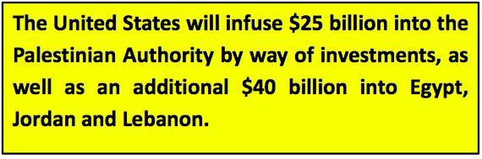
While we appreciate and admire the real estate mogul that wrote, “Trump: The Art of the Deal”, there is no correlation to negotiating a business deal and thinking the President, or anyone else, can negotiate a “deal” when it involves a sworn Covenant by Jehovah. The land promised to Abraham and his descendants Isaac and Jacob (later changed to Israel) is an eternal Oath.
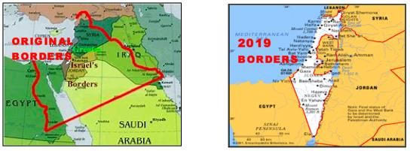

According to Genesis 15:18 and Joshua 1:4 the land God gave to Israel included: everything from the Nile River in Egypt to Lebanon (south to north) and everything from the Mediterranean Sea to the Euphrates River (west to east). Translated today, Jehovah gave Abraham and his descendants all of the land modern Israel currently possesses, all of the land of the Palestinians (the West Bank and Gaza), all the land of Jordan, some of Egypt, Syria, Iraq and Saudi Arabia.
The wording of the President regarding the move of the U.S. Embassy to Jerusalem is spoken like a true businessman negotiating a potential deal in the marketplace:
Trump has publicly stated that Israel will now pay a higher price in peace negotiations with the Palestinians since Israel won “very big” with the recent U.S. Embassy move to Jerusalem. Now the Palestinians “will get something very good…it’s their turn.”¹ At the end of this month, March, Kushner will travel to the five Gulf countries to discuss the specifics and garner regional support for the plan. The Iranian threat to Israel is very real, and this threat is a shared concern by Israel and the Arab countries. The Middle East Peace Plan will be presented and made public by the end of April, which gives Israel time to finish elections on April 9th, and begin transitions based on those elections. Trump wants to move quickly so as not to become bogged down as his own 2020 Presidential Election begins in earnest.
The problem that advisors Kushner, Greenblatt and others fail to realize, and dutifully report to the President, is really very straightforward – the God of Israel does not negotiate.
This is clearly stated in the Book of Malachi chapter 3, “⁶ …for I am the Lord, I do not change [but remain faithful to My covenant with you]; that is why you, O sons of Jacob, have not come to an end.”
Moreover, as for the duration of the Promised Land, Jeremiah chapter 31 states, “³⁵ The Lord, the Lord of All is His name, Who gives the sun for light during the day, and put the moon and the stars in place to give light during the night, Who causes the waves of the sea to make a loud noise, says, ³⁶ “If these laws change before Me, then the children of Israel will stop being a nation before Me forever.”
One more point. Akin to the “plan”, a business deal usually includes an economic aspect. In the case of TIPP; giving Israeli land away, dividing Jerusalem and providing $25 billion to the corrupt and deceitful Palestinian leadership and another $40 billion divvied up between Egypt, Jordan and Lebanon is utopia. In Kushner’s mind every nation in the Middle East will have peace, harmony and non-corrupt governments. As he naively states:
The Trump Middle East Plan redraws Israel’s boundaries and resolves final status issues. Kushner has stated repeatedly the plan will “have a broad economic impact, not only on Israel and the Palestinians, but on the entire region as well.” Kushner claims, “…there is a free flow of people and of goods. We must create new opportunities.” Kushner continued by sharing it is noted the intra-Palestinian political divides – with the PLO in charge in parts of the West Bank and Hamas ruling the Gaza Strip, and further states, “We want to see the Palestinians united under one leadership, the Palestinians want a non-corrupt government that cares for their own interests.”² His statement is true of the ordinary citizen but absolutely naïve when it comes to the leadership.
In proper perspective, the thought of a thriving Middle East with cooperating neighboring nations is delusional – lost in this fantasy are the terrorist regime nation-states of Syria and Iran as well as the global terrorist organizations of Hezbollah, Hamas and remnants of the deadly group, ISIS. Rather than providing U.S. funds to Lebanon (Hezbollah, et al.,), the TIPP could simply cutout the middle-men and give billions more directly to the diabolical Supreme Leader of Iran (Ali Khamenei).
The fallout from TIPP will be politically devastating for President Trump in 2020 and injurious to the United States for years to come. It is simply and unequivocally stated by Jehovah in Genesis Chapter 12, “…I will bless those who bless you, and I will curse [that is, subject to My wrath and judgment] the one who curses (despises, dishonors, has contempt for) you.” Giving Israeli land to the Palestinians, dividing Jerusalem and funding sworn enemies of the Jewish State certainly qualifies as a curse.
As of today, with a desperately needed voting bloc, President Trump enjoys overwhelming support from the “faith based” community with white evangelical support remaining at an all-time high of 75%.³ However, by the millions, this voting bloc stayed home rather than vote in the 2012. The unfathomable and odious TIPP will negatively impact his base and have severe ramifications for the 2020 election.
For the President, as ardent supporters, we do not believe he is being served well by current advisors. As the NWC, we pray that he opens his heart to Godly counsel from those that truly understand prophecy and scripture regarding Israel. You remain in our prayers Mr. President as well as the Prime Minister of Israel.
[March 21, 2019]
Blessings,
Joseph “Jim” Stockstill 
The Unknown Prophet in Texas
“National War Council” – Chairman, Formation Committee
Dallas Metroplex
war.council@yahoo.com
PayPal.Me/warcouncil

“For the weapons of our warfare are not carnal but mighty through God…”
II Corinthians 10:4

- President Donald Trump, “Trump: Israel will pay ‘higher price’ in peace talks after embassy move,” The Times of Israel, August 22, 2018. https://www.timesofisrael.com/trump-israel-will-pay-higher-price-in-peace-talks-after-embassy-move/
- Jared Kushner, “Kushner: US peace plan will demand 'tough compromises' from Israelis, Palestinians,” i24 News, April 23, 2019. https://www.i24news.tv/en/news/international/middle-east/1556034417-kushner-us-peace-plan-will-demand-tough-compromises-from-israelis-palestinians
- Tara Isabella Burton, “The GOP can’t rely on white evangelicals forever,” Vox, November 7, 2018. https://www.vox.com/2018/11/7/18070630/white-evangelicals-turnout-midterms-trump-2020

