
National War Council
“Repair the Breach”

Hamas leader Yahya Sinwar thanked Iran for providing his terror group the rockets it used to strike deep into Israel.
Part 7
Iran leaders mock Trump peace plan as thousands rally on anti-Israel Quds Day
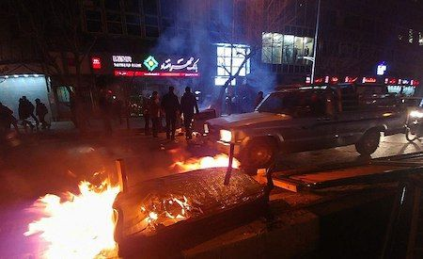Iranian Protests¹
As rallies began across the Iranian capital and 950 other cities and towns, thousands of demonstrators set fire to American and Israeli flags, and also burned effigies of President Donald Trump and Israeli Prime Minister Benjamin Netanyahu. Similar rallies will take place in Iraq and Lebanon. Many high-ranking Iranian officials attended the rally in Tehran, including President Hassan Rouhani and Foreign Minister Mohammad Javad Zarif.
Both men derided the Trump administration’s so-called “Deal of the Century” peace plan, saying it would end in failure.
Hamas leader Yahya Sinwar (pictured) thanked Iran for providing his terror group the rockets it used to strike deep into Israel and warned the Jewish state that Tel Aviv would be struck again in response to any offensive against the Gaza Strip. Sinwar went on to say; “Iran provided us with rockets, and we surprised the world when our resistance targeted Beersheba”¹ referring to the weekend of violence at the beginning of the month, during which Hamas and Palestinian Islamic Jihad fired nearly 700 rockets at Israel.
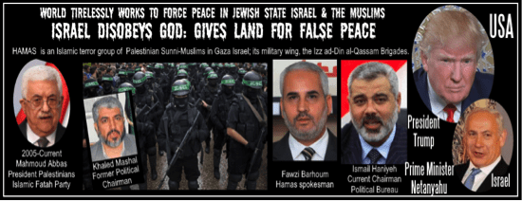
Israel Disobeys God²
As we pointed out previously, “The fallacy of this ‘ultimate deal’ by the ingenious negotiating team is to have the United States, Israel and Sunnis nations (those that attend) negotiate an agreement on behalf of the Shiite backed Palestinians.” Speaking on Palestine TV this past Tuesday, Palestinian Authority President Mahmoud Abbas condemned the Trump peace effort and the upcoming conference in Bahrain stating, “May The Deal of the Century – the Deal of Shame – go to Hell.”
Disregarding the growing opposition and demonstrations of Shiite nations, in an effort to bolster faltering support for their peace plan, Mr. Kushner and team stopped in Morocco where they met with King Mohammed VI and other high-ranking dignitaries. The President’s envoys then went to Jordan to meet with King Abdullah II. Following their meeting with the King, Mr. Greenblatt enthusiastically tweeted, “‘constructive meeting’ with Abdullah that included ‘a good conversation about regional dynamics and our administration’s efforts to help Israel and the Palestinians achieve a brighter future.’”²
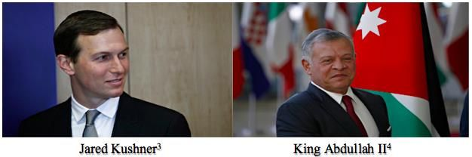
Perhaps the “War Council” missed something from the private meeting, which is understandable, but King Abdullah was quoted as insisting, “…on the need to intensify efforts to achieve a comprehensive and lasting peace based on the two-state solution that would guarantee the establishment of an independent Palestinian state with East Jerusalem as its capital.”³ While Jordan, a key U.S. ally has not committed to attending the conference in Bahrain, Mr. Kushner has stated the conference will not include core political issues, such as Palestinian statehood.
In typical political parlance, Mr. Kushner has signaled that the White House may be pulling back from America’s previous support for a two-state solution. Earlier this month, quoting Kushner, “If you say ‘two-state,’ it means one thing to the Israelis; it means one thing to the Palestinians. We said, ‘you know, let’s just not say it. Let’s just say, let’s work on the details of what this means.’”⁴ With the strong denunciation by the Palestinian Authority and the terrorist group Hamas, Mr. Kushner (The White House) has billed the economic workshop as, “a pivotal opportunity… to share ideas, discuss strategies and galvanize support for potential economic investments and initiatives that could be made possible by a peace agreement.”⁵ In the past, and certainly praying this is not true with President Trump, these investments and initiatives usually leave the American taxpayer footing the bill for billions of dollars.
With the financial, military training and weapons provided by Iran to proxies like Hezbollah, Hamas and the Palestinian Islamic Jihad, as well as opposition from China and Russia, it is hard to fathom the Palestinians will accept; much less abide by, any agreement reached in Bahrain or anywhere else. Besides, the spectacle of the road show and indications that Israel is being coerced (cutting off billions of dollars in annual aid) into participating in this fallacious effort is starting to negatively impact the President’s popularity among some of his key base of evangelical supporters.
We strongly support and appreciate President Trump and his many accomplishments made even before taking the oath of office and pray that he will have his team focus their time, energy and resources on his campaign promise of “Making America Great Again” and in his second term “Keeping America Great!”
[May 31, 2019]
Blessings,
Joseph “Jim” Stockstill 
The Unknown Prophet in Texas
“National War Council” – Chairman, Formation Committee
Dallas Metroplex
war.council@yahoo.com
PayPal.Me/warcouncil

“For the weapons of our warfare are not carnal but mighty through God…”
II Corinthians 10:4

Text Credits:
- JNS, “Hamas Leader Thanks Iran for Rockets, Tools of Terror to Attack Israel,” United With Israel, June 2, 2019. https://unitedwithisrael.org/hamas-leader-thanks-iran-for-rockets-tools-of-terror-to-attack-israel/
- Associated Press, “Jordan’s king tells Kushner the Israel-Palestinian conflict requires two-state solution,” Los Angeles Times, May 29, 2019. https://www.latimes.com/world/la-fg-jordan-king-kushner-israel-palestinian-peace-plan-20190529-story.html
- The Times of Israel, “Jordan king tells Trump team a Palestinian state the only way to peace,” The Times of Israel, May 29, 2019. https://www.timesofisrael.com/jordan-king-tells-trump-team-a-palestinian-state-the-only-way-to-peace/
- Yaron Steinbuch, “Jared Kushner says Mideast peace plan won’t say ‘two states,’” New York Post, May 3, 2019. https://nypost.com/2019/05/03/jared-kushner-says-mideast-peace-plan-wont-say-two-states/
- The White House, “Joint Statement from the United States of America and the Kingdom of Bahrain,” The White House, May 19, 2019. https://www.whitehouse.gov/briefings-statements/joint-statement-united-states-america-kingdom-bahrain/
Image Credits:
- Fars News Agency
- Jesus Our Blessed Hope
- Alexandros Michailidis / Shutterstock.com
- Alexandros Michailidis / Shutterstock.com

